**How to Use the Code Editor**

1. Select the "Run Code" button to execute the program.
2. Select the "Calculate Grade" button to generate a score based on the completed tasks.
3. Continue to modify, run, and calculate your code until you are happy with the grade.
4. Select the "Submit" button to turn in the assignment to your instructor. Complete the coding activity. Your instructor will grade this activity manually.

**How to Use the Code Editor**

1. Select on the "Run Code" button to execute the program.
2. Make any necessary modifications to the code.
3. Continue to modify and run your code until you are happy with the output.
4. Select the "Submit" button to turn in the assignment to your instructor.

**Summary**

Kyle has reviewed your work on the DLR nightly schedule page. He wants you to make a few changes to the layout and apply those changes to a new page that describes the DLR morning schedule. Kyle already has entered much of the web page content and style. He wants you to complete his work by creating and designing the web table listing the times and programs for the morning schedule. *Figure 6–52* shows a preview of the morning schedule page.

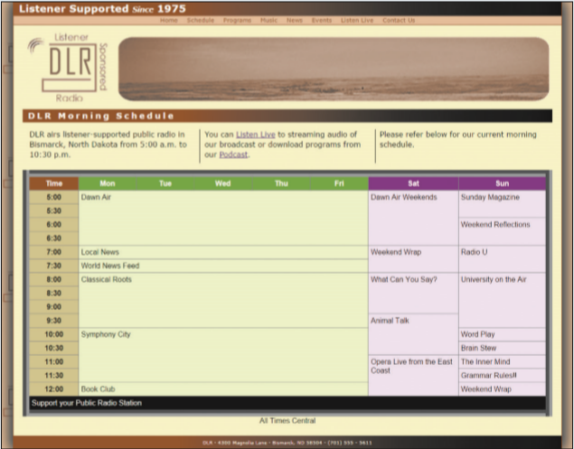 *Figure 6–52*

**Document Setup**

Open the *dlr_mornings.html*, *dlr_tables2.css* and *dlr_columns2.css* files and enter your **name** and the **date** in the comment section of each file. Next, go to the *dlr_mornings.html* file and insert links to the *dlr_tables2.css* and *dlr_columns2.css* style sheets.

**Create the Web Table**

Scroll down the file and directly below the paragraph element, insert a web table and do the following:

* Set the class name of the web table to programs.
* Add a table caption containing the text **All Times Central**.
* insert a colgroup element containing three columns below the caption.
  + set the first col element should have the class name timeColumn.
  + set the second col element should have the class name wDayColumns and span five columns in the table that will contain the weekday programs.
  + set the last col element should have the class name wEndColumns and span the last two columns containing the weekend programming.
* Add the thead row group element containing a single table row with th elements containing the text shown in *Figure 6–52*.
* Add the tbody row group element containing the times and names of the different DLR programs from 5:00 a.m. to 12:00 p.m., Monday through Sunday, in half-hour intervals. The times should be placed in th elements and the program names in td elements.
* Create row and column spanning cells to match the layout of the days and times shown in *Figure 6–52*.
* Add the tfoot row group element containing a single row with a single td element that spans 8 columns and contains the text **Support your Public Radio Station**.

**Table Styles**

Close the *dlr_mornings.html* file and open the *dlr_tables2.css* and go to the "Table Styles" section. Create a style rule for the programs table that:

1. Set the width of the table to **100%**.
2. Add a **15** pixel outset border with a color value of **rgb(151, 151, 151)**.
3. Defines the borders so that they are collapsed around the table.
4. Set the font family to the font stack: **Arial**, **Verdana**, and **sans-serif**.

Create a style rule that sets the height of every table row to **25** pixels and add a style rule for every th and td element that:

1. adds a **1** pixel solid gray border,
2. aligns the cell content with the top of the cell, and
3. sets the padding space **5** pixels.

**Table Caption Styles**

Go to the "Table Caption Styles" section and create a style rule that places the caption element at the bottom of the table and centered horizontally.

**Table Column Styles**

Go to the "Table Column Styles" section. For col elements belonging to the timeColumn class, create a style rule that sets the column width to **10%** and the background color to the value **rgb(215, 205, 151)**.

For col elements of the wDayColumns class, create a style rule that sets the column width to **11%** and the background color to **rgb(236, 255, 211)**. For col elements of the wEndColumns class, create a style rule that sets the column width to **17%** and the background color to **rgb(255, 231, 255)**.

**Table Header Styles**

Kyle wants you to format the table heading cells from the table header row. Go to the "Table Header Styles" section and create a style rule to set the font color of the text within the thead element to **white** and the background color to a **medium green** with the value **rgb(105, 177, 60)**.

The different cells in the table header row should be formatted with different text and background colors. Using the first-of-type pseudo-class, create a style rule that changes the background color of the first th element with the thead element to **rgb(153, 86, 7)**.

Using the nth-of-type pseudo-class, create style rules that change the background color of the **7**th and **8**th th elements within the thead element to **rgb(153, 0, 153)**.

**Table Footer Styles**

Kyle wants the table footer to be formatted in a different text and background color from the rest of the table. Go to the "Table Footer Styles" section. Create a style rule for the tfoot element that sets the font color to **white** and the background color to **black**.

**Column Styles**

Return to the *dlr_columns2.css* file. Kyle wants the introductory paragraph to appear in a three column layout for desktop devices. Within the "Column Styles" section, create a media query for screen devices with minimum widths of **641** pixels. Within the media query, create a style rule for the paragraph element that:

1. sets the column count to **3**,
2. sets the column gap to **20** pixels, and
3. adds a **1** pixel **solid black** dividing line between columns.

Open the *dlr_mornings.html* file in your browser and verify that the table layout and design resemble that shown in *Figure 6–52*.

**Task 1**: When you have completed the assignment, check this task, open the task list and submit your work to your instructor.

**Task #01:** When you have completed the assignment, check this task and submit your work to your instructor.

RUN CODE

SUBMIT